Report about best devices in PC, best operating system and suitable programming languages.
System Name:
- Best Devices
any destop computer or laptop which is able to run the windows operating system.
And the app targets the .net framework or .net core/5+
The app perfomance will depend on the hardware (cpu,ram)
- Best Operating System
Best Operating System: Microsoft Windows (Windows 10, Windows 11).
WPF are designed for windows interface .

- Suitable Programming Languages
C# : for app logic and database connections
XAML : for the UI of the window
SQL : for the database and store the users info.

Design of an integrated system (Class diagram)

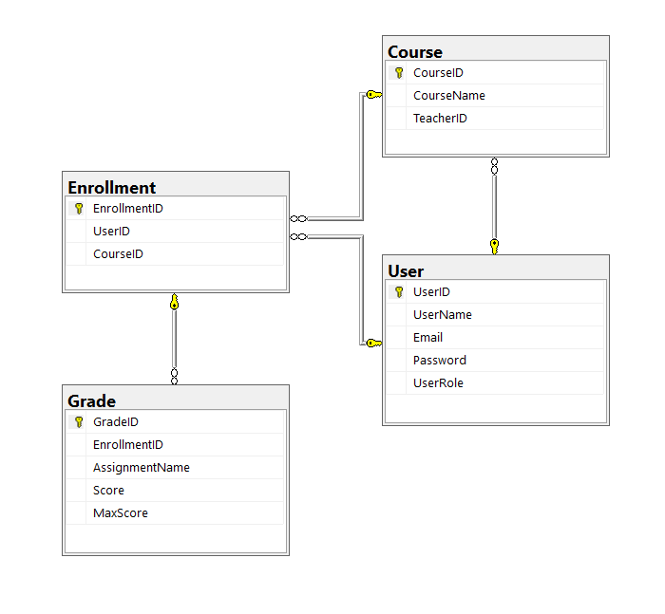

Testing
Test case ID | Test case description | Test Steps | Test Data | Expected Result | Actual Result | Pass/Fail
1 | Login Empty username or empty password | 1. Enter Username  2. Enter password  3. Click 'Login' | username = null  password = null | MessageBox = 'Please Enter Username and Password' | MessageBox = 'Please Enter Username and Password' | Pass
2 | Test Right Username and Wrong Password | Email  2. Enter password  3. Click 'Login' | username = ‘shio@’  password = '123' | MessageBox = 'Invalid username or password' | MessageBox = 'Invalid username or password' | Pass
3 | Test Wrong username and Right password | 1. Enter Username  2. Enter password  3. Click 'Login' | username= 'test'  password = 'shin' | MessageBox = 'Invalid username or password' | MessageBox = 'Invalid username or password' | Pass
4 | Test Enter right username and password to Teacher account | 1. Enter Username  2. Enter password  3. Click 'Login' | username = 'shio@'  password = '123' | Go to Teacher page | MessageBox = 'wrong pass or username' | Fail
5 | Test Enter right username and password to Teacher account | 1. Enter Username  2. Enter password  3. Click 'Login' | username = 'shio@'  password = 'shin'' | Go to Teacher Page | Go to Teacher Page | Pass
6 | Test Enter right username and password to Student account | 1. Enter Username  2. Enter password  3. Click 'Login' | username = 'hamo@'  password ='ham' | Go to Student Page | Go to Student Page | Pass

